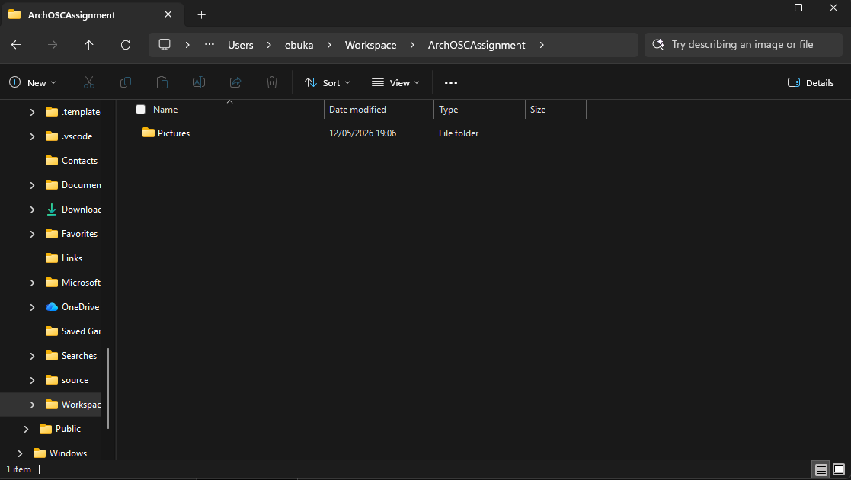
New workspace folder created with new pictures folder added in it
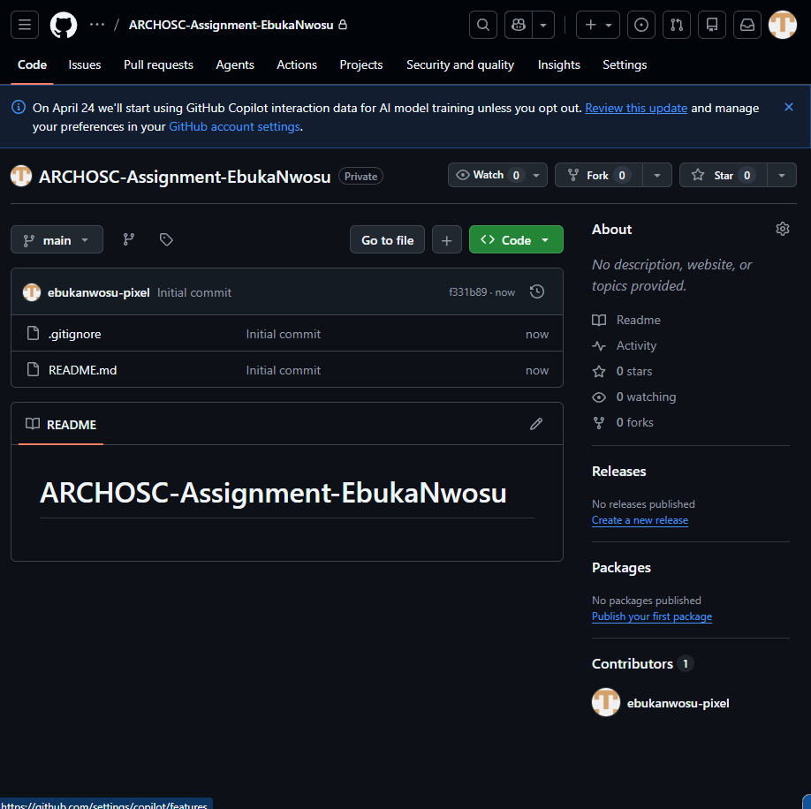
Created a new repository on github
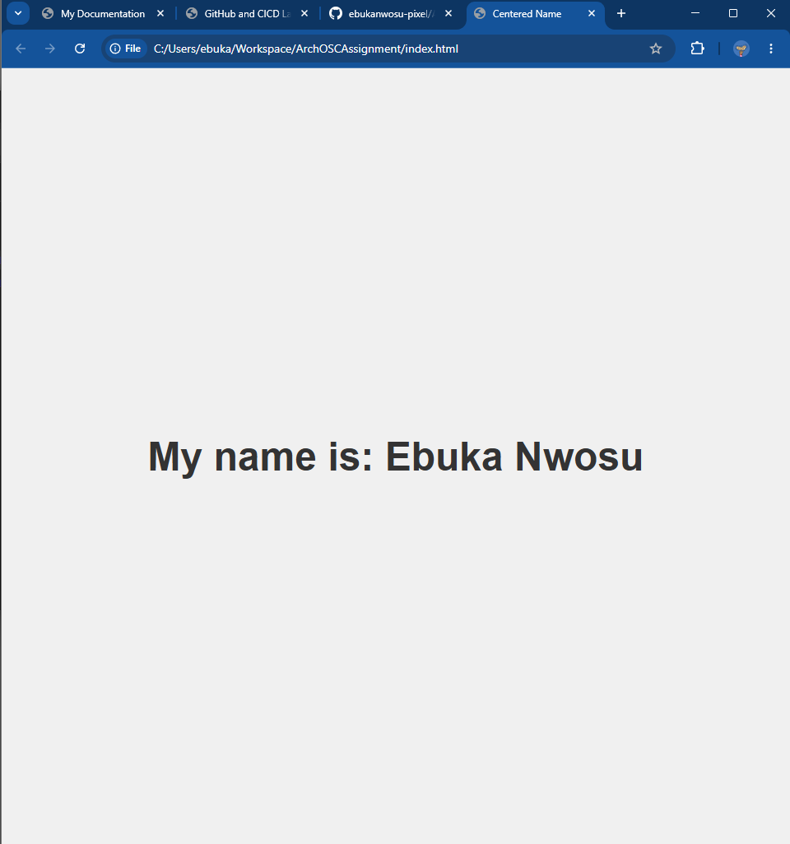
Created a new website with my name centered
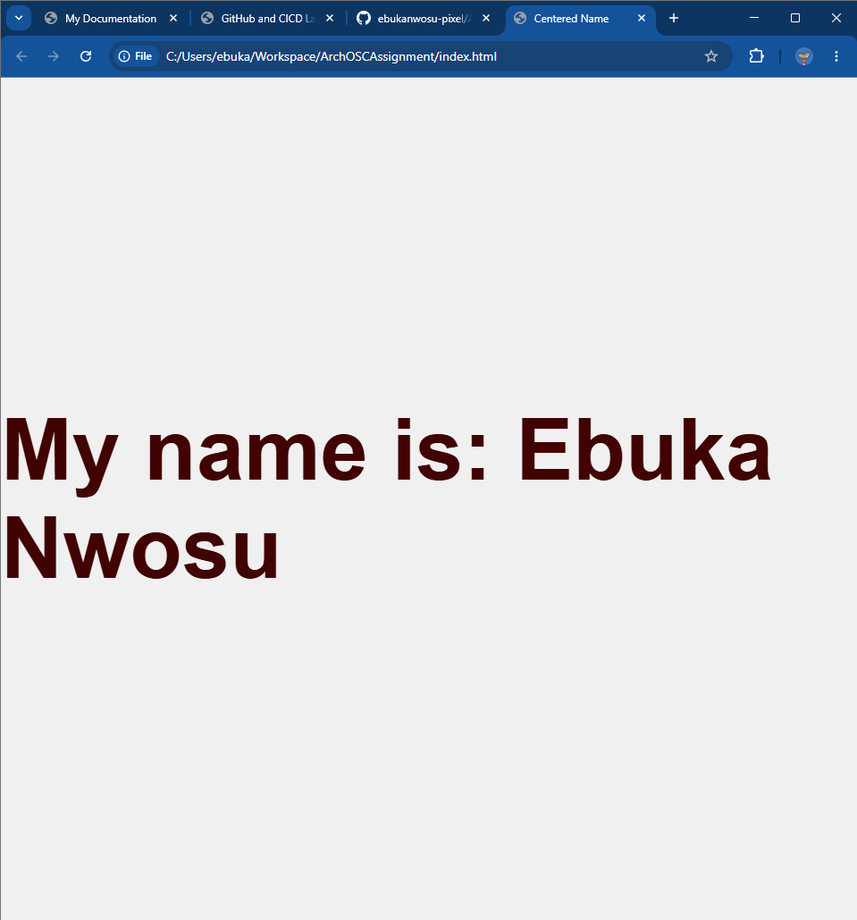
Changed the size and colour of the centered name
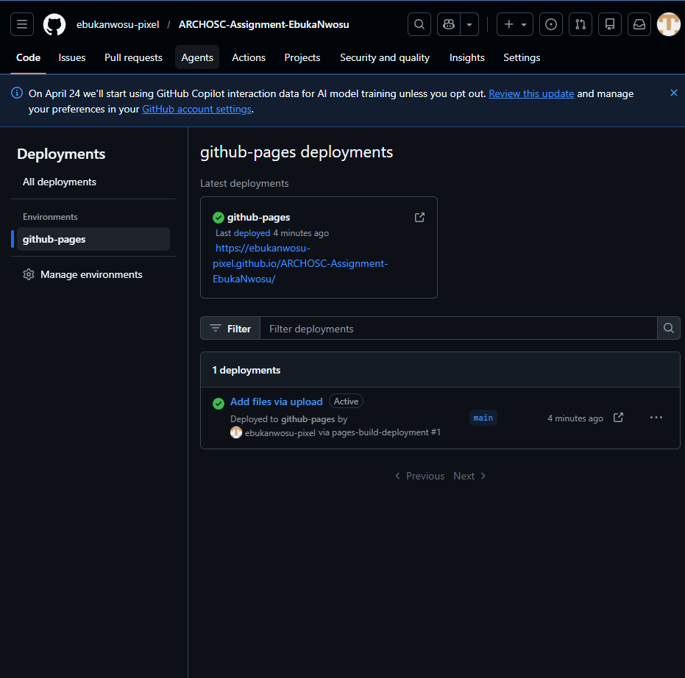
Deployed a webpage on github

Reflection: I've learned an important part of coding; making a website and learning how to push to github is very valuable in preventing data loss

